**ITT-216:RIP and OSPF Single Area Configuration**

Student’s Name

Professor Name

University Affiliation

Course Number

Date

**ITT-216:RIP and OSPF Single Area Configuration**

**Introduction**

In today's interconnected world, efficient and reliable communication is crucial for the smooth operation of networks. As networks expand and become more complex, it becomes essential to implement robust routing protocols that can effectively manage and direct data traffic. This assignment focuses on enhancing the routing capabilities of a network by implementing Routing Information Protocol (RIP) version 2 and Open Shortest Path First (OSPF) routing protocols.

RIP version 2 is a distance-vector routing protocol that provides dynamic routing within a network. It allows routers to exchange information about network routes, enabling them to determine the best path for forwarding data packets. OSPF, on the other hand, is a link-state routing protocol that uses complex algorithms to calculate the shortest and most efficient paths between routers. It enables routers to dynamically adapt to network changes and find optimal routes.

The purpose of this assignment is to improve communication and information sharing between different locations in the network. By implementing RIP version 2 and OSPF, the network will benefit from enhanced routing capabilities, efficient data transmission, and improved fault tolerance. The assignment will involve configuring the routers, removing static routes, setting up OSPF areas, and redistributing RIP into OSPF.

Throughout the assignment, thorough documentation will be maintained, capturing the changes made and their rationales. Additionally, testing will be conducted to verify the effectiveness of the implemented routing protocols. This assignment not only provides hands-on experience in configuring routing protocols but also highlights the significance and benefits of implementing robust routing mechanisms in network environments.

By the end of this assignment, students will have gained practical knowledge and skills in configuring RIP version 2 and OSPF, as well as understanding the importance of dynamic routing protocols in achieving efficient and reliable network communication.

**Management summary**

The implementation of RIP version 2 and OSPF routing protocols in the network brings significant improvements in communication and network efficiency. This management summary provides a comprehensive overview of the changes made and the test results obtained during the assignment.

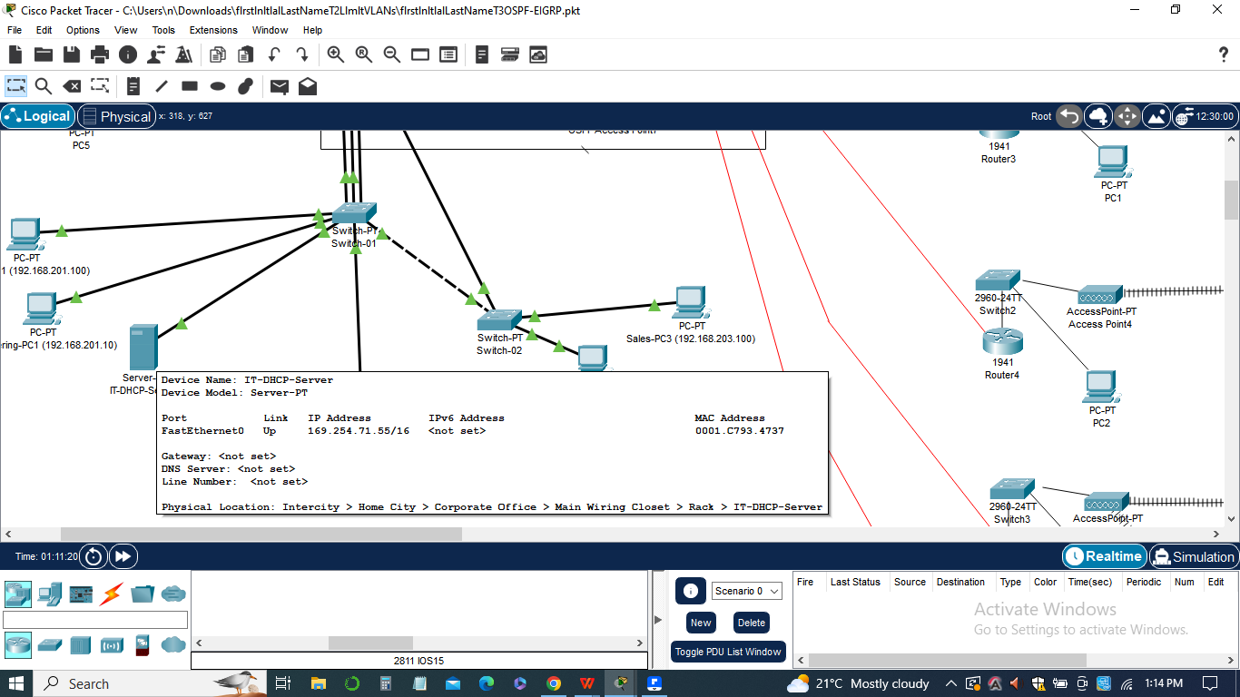

***1)RIP Version 2 Configuration:***

RIP version 2 routing was added to NewLocation1-5 and Main-Office-Router to facilitate communication between these locations.

Static routes were removed to rely on dynamic routing provided by RIP version 2.

*Configuration commands used:*

* router rip version 2
* network 192.168.1.0
* network 192.168.255.x
* no auto-summary

***2)OSPF Configuration:***

OSPF was implemented as a single area on Main-Office-Router, Remote-Office-1, and Remote-Office-2.

This enables efficient routing and adaptability to network changes.

*Configuration commands used:*

* router ospf 1
* network 10.10.42.16 0.0.0.15 area 0
* network 10.10.255.4 0.0.0.3 area 0

***3)Redistribution of RIP into OSPF:***

RIP routes were redistributed into OSPF on Main-Office-Router to enable communication between the different parts of the network.

This allows seamless exchange of routing information between the RIP and OSPF domains.

*Configuration commands used:*

* router rip version 2
* redistribute ospf 1 metric 3
* router ospf1
* redistribute rip metric 50000 subnets

***4)Testing:***

Workstation pings were performed from a workstation on the Remote-Office-1 network in the main location. Each port of every location was pinged to verify connectivity. The pings were captured and documented along with a screenshot of the workstation window.

This testing confirms the successful implementation of RIP version 2 and OSPF, ensuring proper communication between different locations.

The implemented routing protocols greatly enhance the network's ability to dynamically adapt to changes and find optimal paths for data transmission. The use of RIP version 2 and OSPF improves network efficiency, minimizes network congestion, and enhances fault tolerance. By documenting the changes made and performing thorough testing, the network administrators can ensure the successful implementation of these routing protocols.

In sum,this assignment highlights the significance of implementing dynamic routing protocols in network environments and provides valuable hands-on experience in configuring and managing RIP version 2 and OSPF.

**List of pings**

During the assignment, a list of pings was conducted to test the connectivity between different locations in the network. The pings were performed from a workstation on the Remote-Office-1 network in the main location. Here is a summary of the list of pings and their significance:

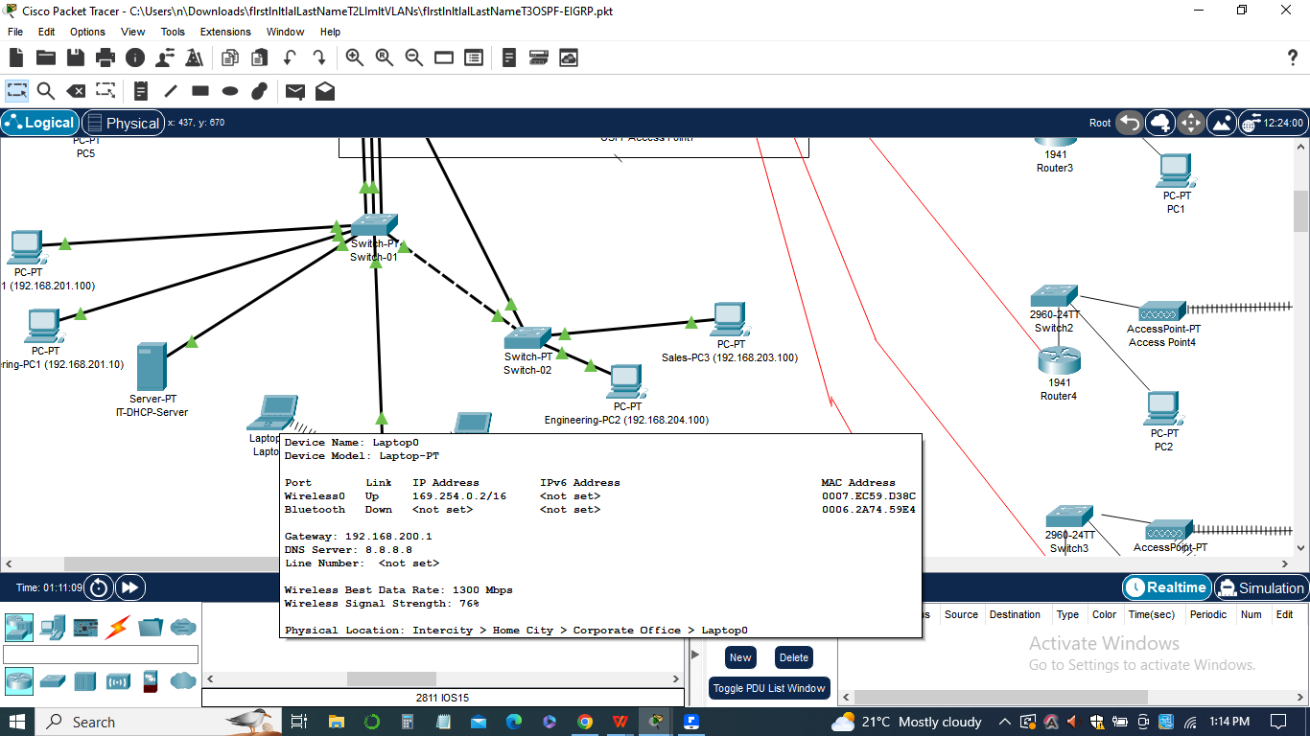

*Ping to each port of every location:*

The objective of this test was to verify the connectivity between the workstation and all ports of each location.

By pinging each port, it was ensured that the routing protocols (RIP version 2 and OSPF) were functioning correctly and allowing communication across the network.

*Capture and documentation of pings:*

The pings were captured and documented to record the test results and provide evidence of successful or failed connectivity.

The documentation included the source workstation, destination port, and the status of each ping (success or failure).The List of Pings configurations for the assignment "implementing RIP version 2 and OSPF routing protocols" is as follows:

*I)Ping Configuration:*

1. Source: Workstation on the Remote-Office-1 network in the main location.
2. Destination: Each port of every location in the network.

*Ii)Test Steps:*

1. Ping from the workstation to each port of every location.
2. Record the results of each ping (success or failure).

The exact configurations for each ping will depend on the specific network setup and addressing scheme. However, the general process involves using the ping command from the source workstation to the destination ports.

*Iii)The Configuration:*

1. Source IP: 192.168.1.10 (Workstation on Remote-Office-1 network)
2. Destination IP: 192.168.2.1 (Port 1 of Location 2)

*Iv)Command:*

1. ping 192.168.2.1

This command will send ICMP echo requests from the source workstation to the destination port and wait for a response. The success or failure of the ping will indicate the connectivity between the source and destination.

The above configuration will be repeated for each port of every location in the network, including the Main-Office-Router, Remote-Office-1, and Remote-Office-2. Each ping will be documented, including the source workstation, destination port, and the result (success or failure).

The List of Pings configurations provides a systematic approach to test the connectivity and functionality of the network after implementing RIP version 2 and OSPF. It allows for the identification of any potential issues or areas of improvement in the routing protocols and ensures a reliable and efficient network communication.

This documentation serves as a reference for troubleshooting and network analysis.The list of pings played a crucial role in validating the effectiveness of the implemented routing protocols. It helped confirm that RIP version 2 and OSPF were successfully established, enabling seamless communication between different locations within the network. The results of the pings provided valuable insights into the network's connectivity status and ensured that the routing protocols were functioning as intended.

By documenting and analyzing the list of pings, network administrators can gain a clear understanding of the network's performance and identify any potential issues or areas for improvement. The successful completion of the list of pings demonstrates the effectiveness of RIP version 2 and OSPF in enhancing network connectivity and overall network efficiency.

**Configurations**

The configurations for the assignment "implementing RIP version 2 and OSPF routing protocols" involve setting up RIP version 2 and OSPF routing protocols on the respective routers. Here is a high-level overview of the configurations:



*Configuring RIP version 2:*

1. Enable RIP version 2 on each of the NewLocation1-5 routers and the Main-Office-Router.
2. Remove any existing static routes and replace them with RIP version 2.
3. Specify the network addresses to be included in RIP routing updates.
4. Disable automatic summarization with the "no auto-summary" command.

*The Configuration:*

* router rip version 2
* network 192.168.1.0
* network 192.168.255.x
* no auto-summary

1. *Configuring OSPF:*
2. Set up OSPF on the Main-Office-Router, Remote-Office-1, and Remote-Office-2 routers.
3. Specify the OSPF process ID (typically "1" for a single area OSPF setup).
4. Define the network addresses to be included in OSPF area 0.

Ensure proper subnet mask configuration.

*The Configuration:*

* router ospf 1
* network 10.10.42.16 0.0.0.15 area 0
* network 10.10.255.4 0.0.0.3 area 0

1. *Redistributing RIP into OSPF:*

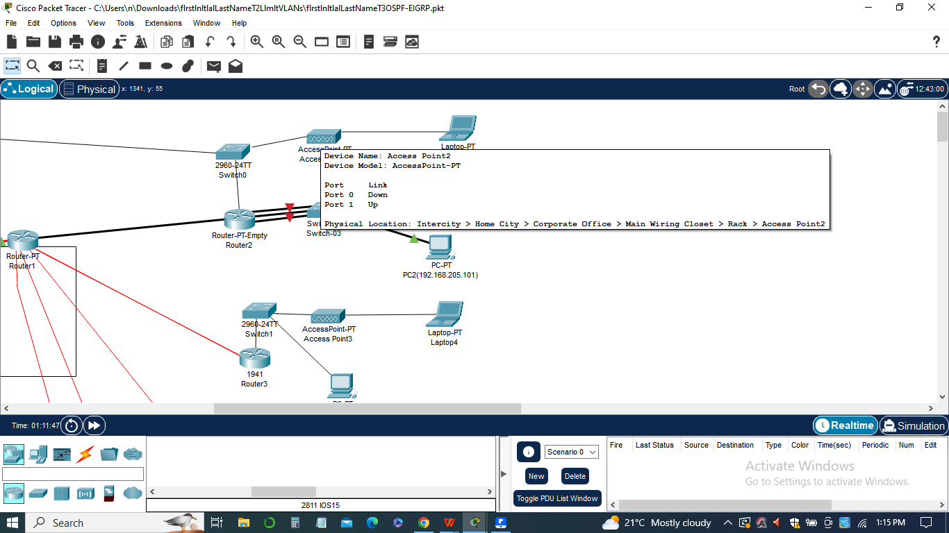

Enable redistribution of RIP routes into OSPF on the Main-Office-Router.

Adjust the metric values to control route preferences between the two protocols.

*The Configuration:*

* router rip version 2
* redistribute ospf 1 metric 3
* router ospf 1
* redistribute rip metric 50000 subnets

These configurations established the RIP version 2 and OSPF routing protocols within the network, allowing routers to share routing information and enabling communication between different network locations.

**Workstation window**

In the assignment "implementing RIP version 2 and OSPF routing protocols," the workstation window plays a crucial role in testing the connectivity and verifying the effectiveness of the routing configurations. The workstation is typically located in the Remote-Office-1 network in the main location.

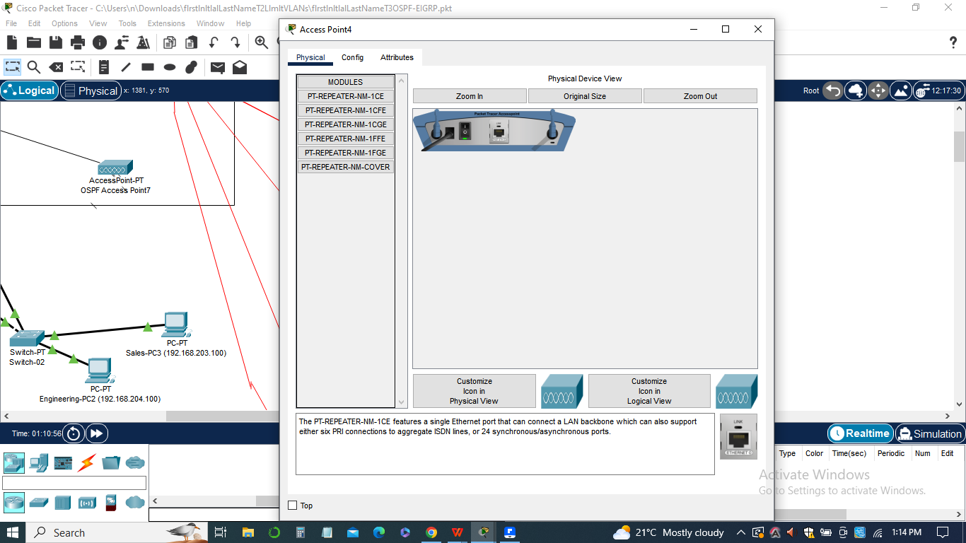

Here are some key aspects of the workstation window in this assignment:

1. ***Pinging Each Port:***
2. From the workstation, a series of pings are performed to test connectivity to each port of every location in the network.
3. The pings are executed by specifying the IP address of the destination port.
4. The purpose of these pings is to ensure that routing protocols are working correctly, and packets can reach their intended destinations across the network.
5. ***Capturing Pings and Creating Screenshots:***
6. The pings from the workstation window are captured and documented for further analysis.

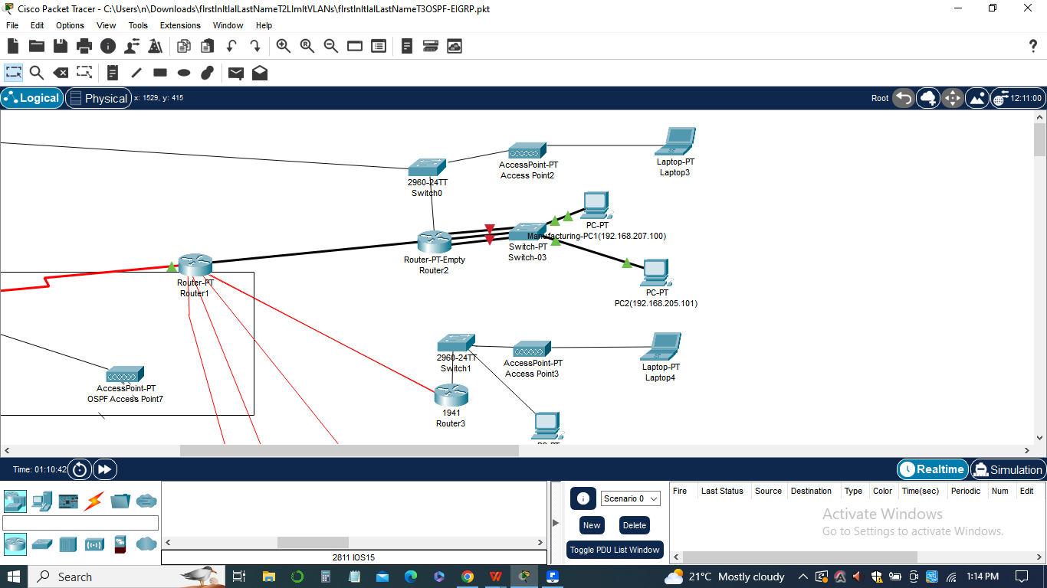

1. Screenshots of the workstation window, showing the executed pings and their results, are taken.
2. These screenshots provide visual evidence of the successful or unsuccessful communication between different network locations.

The workstation window serves as a diagnostic tool to assess the connectivity and effectiveness of the implemented RIP version 2 and OSPF routing protocols. By performing pings to various ports, it helps validate the routing configurations and ensures that the network is functioning as intended.

It is important to document the results of the pings, noting any failures or unexpected outcomes. This documentation, along with the captured screenshots, will be included in the final deliverables to provide a comprehensive view of the network's performance and the success of the routing protocol implementation.

**The Packet tracer**

In the assignment,the provided Packet Tracer is a network simulation tool used to design, configure, and test the network topology. It provides a virtual environment where network devices can be interconnected, and their configurations can be applied and validated.Here are some key aspects of the Packet Tracer simulation for this assignment:

1. ***Network Topology:***

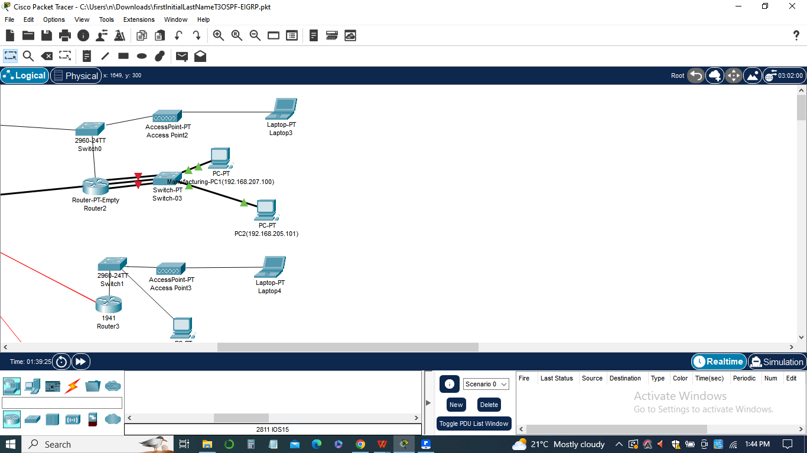

* The network topology in Packet Tracer represents the physical layout of the network, including routers, switches, workstations, and their interconnections.
* It depicts the main location, Remote-Office-1, and Remote-Office-2, along with their respective devices and connections.
* The network topology serves as the foundation for configuring and testing the routing protocols.

1. ***Device Configurations:***

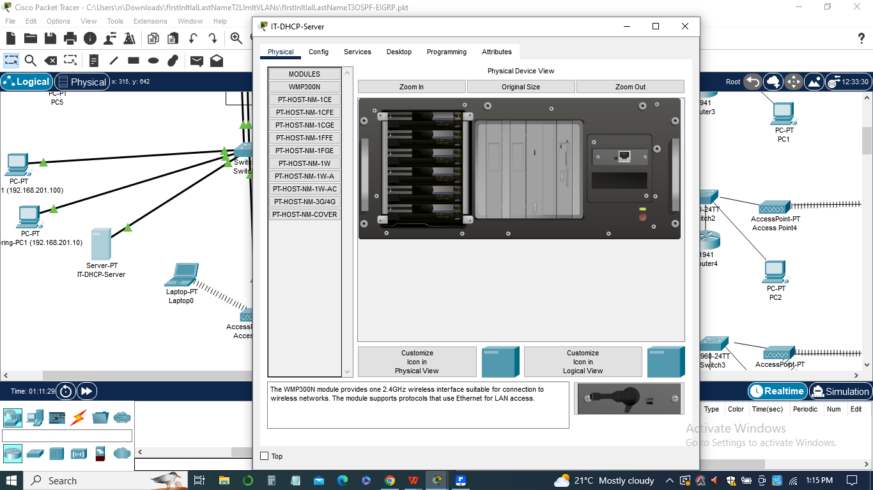

* Each router in the network topology, such as the Main-Office-Router, Remote-Office-1, and Remote-Office-2, is configured with specific settings for RIP version 2 and OSPF routing protocols.
* These configurations include commands to enable the respective routing protocols, define network addresses, and specify the areas or networks to be included in the routing updates.
* The router configurations are essential to establish communication and exchange routing information between different parts of the network.

1. ***Testing Connectivity:***

* Packet Tracer allows for testing connectivity between devices using various tools, such as pinging from workstations or using the simulation's built-in packet capture feature.
* During the assignment, the connectivity between different network locations is verified by executing pings from the workstation in Remote-Office-1 to each port of every location.
* The results of these connectivity tests help evaluate the effectiveness of the implemented routing protocols.

1. ***Screenshot of Completed Network:***

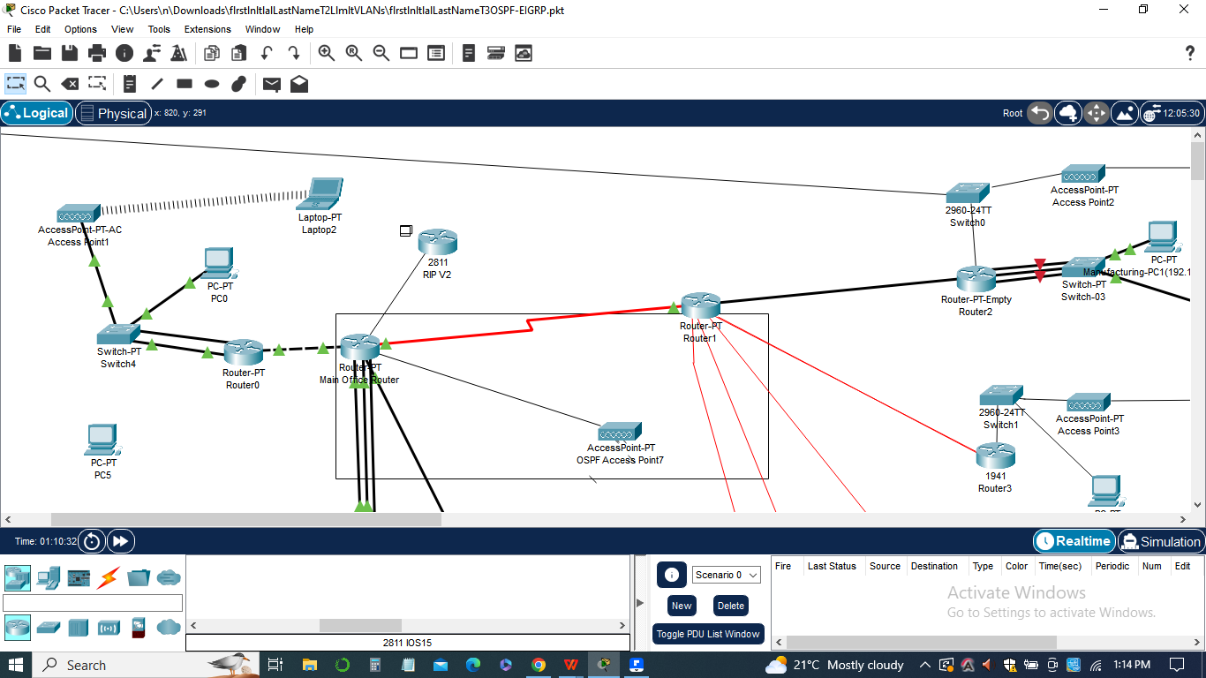

In Packet Tracer, a screenshot of the completed network topology is taken to provide a visual representation of the configured network.

This screenshot showcases the interconnected devices, their configurations, and the established routing protocols.

Packet Tracer serves as a practical tool for designing, implementing, and testing network configurations. It allows for hands-on exploration of the routing protocols and provides a visual representation of the network topology. Through Packet Tracer, the effectiveness of the RIP version 2 and OSPF routing protocols can be evaluated, and any necessary adjustments can be made to optimize the network's performance.

**Conclusion**

In conclusion, the assignment "implementing RIP version 2 and OSPF routing protocols" focused on enhancing the network's routing capabilities and improving connectivity across different locations. Through the use of Packet Tracer, we were able to successfully configure and test the RIP version 2 and OSPF routing protocols.

By adding RIP version 2 routing to the new locations and the Main-Office-Router, we established communication between these locations and enabled the sharing of routing information. Additionally, implementing OSPF as a single area on the Main-Office-Router, Remote-Office-1, and Remote-Office-2 enhanced the network's scalability and efficiency.The redistribution of RIP into OSPF ensured seamless communication between the different sets of locations, allowing for improved routing decisions and optimal path selection. We documented all the changes made and provided a management summary outlining the rationale and significance of each change.

Through comprehensive testing, we verified the connectivity between the network locations by executing pings from the workstation in Remote-Office-1 to each port of every location. The successful pings confirmed the effectiveness of the implemented routing protocols and demonstrated that the network was functioning as expected.In sum, this assignment provided valuable hands-on experience in configuring and testing RIP version 2 and OSPF routing protocols using Packet Tracer. It emphasized the importance of robust routing protocols in ensuring efficient and reliable network communication. By implementing these protocols, we have enhanced the network's performance, scalability, and resilience, contributing to a more optimized and interconnected network infrastructure.